Runwell Hospital Bowls Club
www.runwellbowlsclub.co.uk

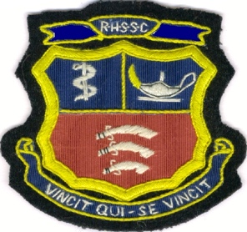

INVITATION MIXED FOURS
(2 LADIES 2 MEN)
SUNDAY 11TH JUNE 2023
Entry fee £48.oo per team
Includes welcoming drink and Lunch
-Cash prizes -
Sausage/Bacon rolls available from
8.30am/Refreshments available all day
Dress Code: Whites
………………………………………………………………………………
Entry form – Mixed Fours: Cheques payable to Runwell Hospital Bowls Club or Direct payment to National Westminster Bank Sort Code: 55-50-28
A/C No. 60502312

Name:…………………………………………………………………………………………………………

Address:…………………………………………………………………………………………………………

……………………………………………………………………………………………………………………….

Post Code:……………………………………Telephone/Mobile…………………………………….

Club……………………………………..E-mail………………………………………………………..

I would like to enter ……………….team(s) in the above competition and enclose a cheque for/ or/ have made direct payment of …………………….
I agree to abide by the rules of the tournament. Signed:……………………..
Return To: Jeanette Mizen, 14 Mount Road, Wickford, SS11 8HE
Or e-mail Mizen56@outlook.com Tele: 01268 462228/07982715166

